Relevant cost: To be a relevant cost it should be differential cost (i.e. different between alternatives) and Future cost (i.e. not sunk). A Relevant cost has two fundamental characteristics:
A: Relevant Costs are Future Cost
B: Relevant Costs are Differential costs.

Decision to Drop a product line
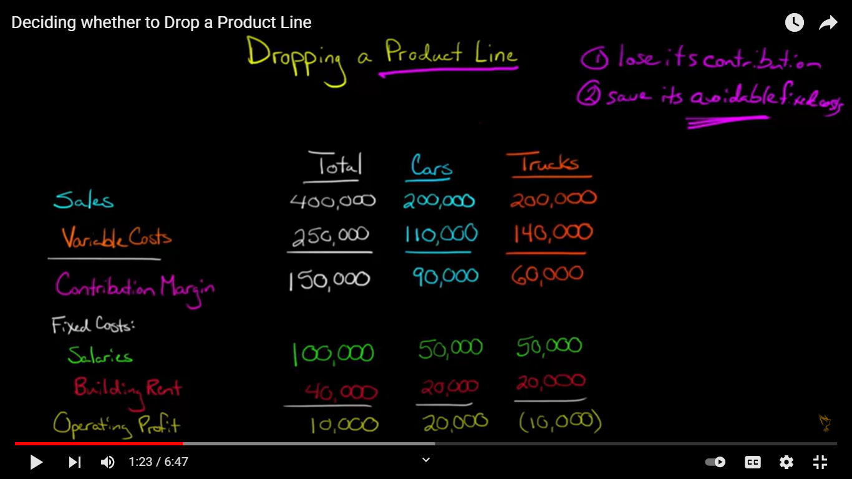
Decision Criteria: Drop the product line if profit increases while dropping the product line.
When a firm is divided into multiple sales outlet, product lines, departments, it needs to evaluate their individual performance to decide on continuing each segment as a loss making segment is better to shut down.
Please note: Allocated fixed cost (Unavoidable for e.g. Rent) cannot be saved if one segment is shut down so will decrease the operating income of the continuing department and Departmental Fixed cost (Avoidable for e.g. salaries, insurance, taxes etc) can be saved.
Let us consider the following example:
A discount department store has three major departments: Groceries, General Merchandise, and Drugs. The management is considering dropping groceries, which have consistently shown a net loss. The present annual net income is reported in the following table (in Thousands Rupee)
Details | Total | Groceries | General Merchandise | Drugs
Sales | 6650 | 3500 | 2800 | 350
Variable cost | 4970 | 2800 | 1960 | 210
Contribution | 1680 | 700 | 840 | 140
Fixed cost
Avoidable DPT | 927.5 | 525 | 350 | 52.5
Unavoidable Al | 630 | 210 | 350 | 70
Total fixed expense | 1557.5 | 735 | 700 | 122.5
Operating Income | 122.5 | (35) | 140 | 17.5

The Vacated space will be idle and the unavoidable costs would continue.

Details | Keep Groceries (Total) | Differential | Drop Groceries
 |  |  | Total | General Merchandise | Drugs
Sales | 6650 | (3500) | 3150 | 2800 | 350
Less: V.C | 4970 | 2800 | 2170 | 1960 | 210
Contribution | 1680 | (700) | 980 | 840 | 140
Less: F.C
Avoidable | 927.5 | 525 | 402.5
Unavoidable | 630 |  | 630
Total Fixed Cost | 1557.5 |  | 1032.5
Net Income | 122.5 | (175) | (52.5)

Q: Himalayan Company has three products A, B & C. The other relevant details concerned to this company have been summarized below.
Particulars | A | B | C | Total
Production Capacity | 40% | 40% | 20% | 100%
Sales Units | 2,000 | 2,000 | 2,000 | 6000
Sales revenue | 10,00,000 | 8,00,000 | 2,00,000 | 20,00,000
Less: V.C | 2,00,000 | 1,60,000 | 80,000 | 4,40,000
Contribution margin | 8,00,000 | 6,40,000 | 1,20,000 | 15,60,000
Less: Alocated F.C | 2,40,000 | 2,00,000 | 80,000 | 5,20,000
Departmental F.C | 60,000 | 40,000 | 20,000 | 1,20,000
Total Fixed Cost | 3,00,000 | 2,40,000 | 1,00,000 | 6,40,000
Net Income | 5,00,000 | 4,00,000 | 20,000 | 9,20,000
Additional Info: Company wants to diversify the sales of product A and B by dropping out product C and utilize the capacity of product C into A & B equally. If company does so, company assumes it would gain more profit as product A and B are more demanded and can be sold as much as produced.
Required: Is the assumption of Himalayan Company right?
Solution: C is operating at 20% capacity which will be equally utilized by A and B which are operating at 40% capacity each. So the new capacity will increase by 10% each.
Therefore now at 50% capacity number of units of A produced will be 2000 * 50/40 = 2500 units. Similarly 2500 units of B will be produced
Details | Keep C (Total) | Differential | Drop C
 |  |  | Total | A | B
Sales units | 6000 | (1000) | 5000 | 2500 | 2500
Sales revenue | 20,00,000 | 2,50,000 | 22,50,000 | 12,50,000 | 10,00,000
Less: V.C | 4,40,000 | (10,000) | 450000 | 250000 | 200000
Contribution | 15,60,000 | 2,40,000 | 18,00,000 | 10,00,000 | 8,00,000
Less: F.C | 640000 | 0 | 6,40,000
Operating Income | 9,20,000 | 2,40,000 | 11,60,000

Replacement of Assets
In a decision to replace or retain equipment, management compares the costs of replacing and retaining. Generally the relevant cost to be considered in a replacement decision are operating cost of the equipments, cost of the new equipment and cash disposal value of the old Equipment.
Please note Book value of the machine is a sunk cost and is not relevant in the decision making.
Details | Old scanner | New scanner
Cost | 1,40,000 | 1,20,000
Annual Operating Costs | 55,000 | 15,000
Remaining Useful Life | 5 years | 5 years
Current resale value | 38,000

Should the new scanner be purchased?
Solution:
Comparative cost statement.
Particulars | Keep old Scanner | Difference | Buy New Scanner
Operating cost of the Equipments
Cost of the New Equipment
Cash Salvage value of the Old equipment
Total Cost

Q) Valley Pizza’s owner brought his current pizza Oven two years ago for Rs 9,000 and it has one more year of life remaining. He is using straight line depreciation for the oven. He could purchase a new oven for Rs 1900, but it would last only one year. The owner figures the new oven would save him Rs 2600 in annual operating expenses compared to operating the old one. Consequently, he has decided against buying the new oven, since doing so would result in a “loss” of Rs 400 over the next year.
Required: a.Criticize the owner’s analysis and decision.
b. Prepare a correct analysis for the owner’s decision.

Comparative cost statement for a year
Particulars | Keep old Oven | Difference | Buy New Oven
Operating cost of the Equipments
Cost of the New Equipment
Cash Salvage value of the Old equipment
Total Cost

